**Thread Management using POSIX Library - Detachment and Cancellation assignments**

**1. Write a program to create 3 threads with the detach and cancel status as below.**

**Thread# Detached (Y/N) Cancel type Cancel status**

**1 Y PTHREAD_CANCEL_DISABLE**

**2 N PTHREAD_CANCEL_ENABLE PTHREAD_CANCEL_DEFERRED**

**3 N PTHREAD_CANCEL_ENABLE PTHREAD_CANCEL_ASYNCHRONOUS**

**a. Let all the threads read and display their detach, cancel type and status and then display thread specific message as below.**

**T1: Display message in the format as below every 2 secs**

**<timestamp> Health OK**

**T2: Print numbers starting from 1000 in steps of 2 at an interval of 3 secs in format as below.**

**<timestamp> <threadid> <countvalue>**

**T3: Print numbers starting from 2000 in steps of 2 at an interval of 3 secs**

**<timestamp> <threadid> < countvalue >**

**b. After creating threads, and after 3 minutes from main(), cancel all 3 threads**

**c. From an other terminal, use command below to view the thread count of your program**

**§ ps -eLF**

**§ top [For top command usage to refer https://www.golinuxcloud.com/check-threads-per-process-count-processes/ ]**

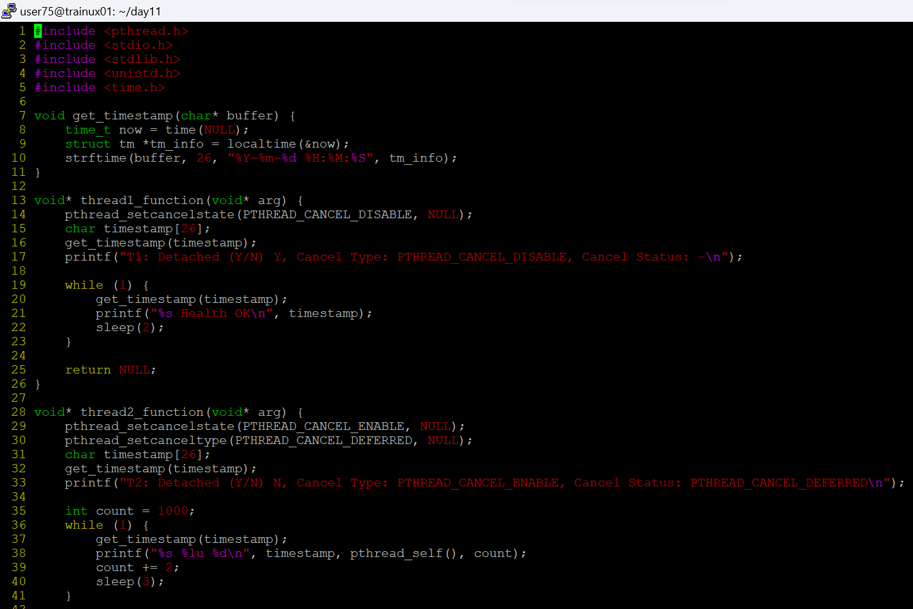



**d. What difference did you observe between top and ps command?**

The ps command shows the threads as individual lines for a process with the -L option. It lists threads by their thread ID (TID) under the same process. In contrast, top shows a total number of threads and may show threads under the same process but in a less granular way compared to ps.

**e. Which column shows the number of threads in ps and in top commands?**

* In the ps command, use the -L option to see the threads, and the column showing the thread count is labeled NLWP (Number of Light Weight Processes, which refers to threads).

* In top, the thread count is shown in the summary section at the top as Tasks and shows the number of threads.

**f. Check the last message timestamp from the threads**

After canceling the threads, check the last printed timestamp in the console for each thread. The output of the program should show when each thread last printed a message before cancellation.

**g. Which thread was cancelled first and why?**

*Thread 1, which is detached and has cancellation disabled (PTHREAD_CANCEL_DISABLE), cannot be canceled until the program terminates, so it won't be affected immediately.

*Thread 3, having asynchronous cancellation (PTHREAD_CANCEL_ASYNCHRONOUS), will likely be canceled first as it is immediately responsive to cancellation requests.

*Thread 2, with deferred cancellation, may continue running until it hits a cancellation point.

**h. Were all 3 threads cancelled? Justify the observation**

* Thread 1 will not be canceled because cancellation is disabled.

*Thread 2 will be canceled after reaching a cancellation point (it is using deferred cancellation).

* Thread 3 will be canceled immediately due to asynchronous cancellation.